GRADUATION INTERNSHIP REPORT



Aggregated Data Management in a Digital Portfolio

|  |  |
| --- | --- |
| Data student: | |
| Full name: | Edita Pronckute |
| Student number: | 3907872 |
| Assignment period: | 06.02.2023 – 30.06.2023 |
| Data company: | |
| Name company/institution: | Drieam |
| Department: | Product & Development |
| Address: | Don Boscostraat 4, 5611 KW Eindhoven |
| Company tutor: | |
| Family name, initials: | Coline van Leeuwen |
| Position: | Software Developer |
| Signature: |  |
| University tutor: | |
| Full name: | Jo-An Kamp |
| Final report: | |
| Title: | Improving Usability of Portflow Evidence Section |
| Portfolio repository: | https://github.com/EditaAnomaly/S8-GI-Drieam/wiki |
| Date: | 07.06.2023 |

Foreword

This report is an overview of the Graduation Internship program of the Fontys University of Applied Sciences carried out at the Drieam ed-tech company. It is written using APA style format following the provided Internship Report Guidelines Template.

The aim of the internship was to improve the usability of a part of the Drieam’s product. The product is a digital portfolio called Portflow and the focus was on improving the aggregated data management within the portfolio for students.

During this internship I was a part of a development team working on improving and maintaining the Portflow. The team consisted of several full-stack developers with years of experience in the field. I was the member responsible for the research, design and the development of the My Evidence section of the product. It is the section that enables users to manage all their aggregated data (evidence). This paper is an overview of my efforts, mostly focused on the process and results of the completed work.

I have grown a lot during these last 5 months, both professionally and personally. The guidance received during this internship was greatly appreciated, the support from my tutor and mentors helped me face my challenges and become a better developer.

Contents

Summary 1

Glossary 2

Chapter 1: Introduction 3

Chapter 2: Assignment Overview 4

2.1 Opportunities 4

2.2. Goals 4

2.3. Approach 5

Chapter 3: Process and Results 6

3.1 Research 6

3.2 Design 6

3.3 Realization 8

Chapter 4: Conclusions and Recommendations 10

4.1. Advice 10

4.2 Management 13

Personal Reflection 14

References 16

Summary

This report describes the duration of the graduation internship at Drieam, an education technology company. It offers various software solutions that aid educators and students.

The assignment was to find a way to improve the usability of Portflow Evidence Section. The section responsible for managing all aggregated data and is only accessible to the owner of the portfolio. The work began in a team of 5-9 developers and design thinking was the chosen approach. First, I learnt more about the company, their culture and products. Second I looked into the competitors to gain insight into the existing products in the market. This helped to better understand the existing problem/ opportunity and start visualizing the potential solution that was later implemented.

The lead concept was created after several iterations of sketching and wireframing the potential solutions then reviewing them with the stakeholders. The final product is a reinvented evidence table that provides a better overview of all aggregated evidence as well as offers tools to manage it. The solution is a production ready code that should be deployed and available to the users as of the next study year.

The internship concluded with testing the solution with students that already are familiar with the product.

Glossary

|  |  |
| --- | --- |
| Notation | Description |
| EdTech | Academic preparation of students using digital means. |
| LMS | Learning Management System that offers administration, automation and tracking of educational courses, training programs and materials. |
| LTI | Learning Tools Interoperability is a series of edtech specifications for a standard that enables applications to be integrated with a LMS. |
| PR | Pull Request is an event where one developer asks another to review the code that they would like to merge into the project in the context of version control management system. |
| Tender | A formal process where businesses are bidding and competing for a contract that requires specific skills or services on an ongoing basis. |

# Chapter 1: Introduction

Drieam is an ed-tech company that was founded in 2014 by Gaston, Tim and Bart. While studying at the Eindhoven University of Technology, they had a shared vision of changing the way students interact digitally. Thus, the name of the company – three students with a shared dream. One of the first applications, they created was FeedPulse, that enabled educators and students to digitally share feedback as a central part of the learning process. It was very successful and is being actively used by Fontys students too.

Since then, the company has grown to over 50 employees building and maintaining many more applications. The Drieam has become the market leader in its field in the Benelux region and is even expanding overseas. Prestigious universities such as Yale, Cambridge and IMD use Drieam’s applications on a daily basis.

Portflow is another successful product of the company. It is a student-led development and assessment portfolio application. It was developed adhering to the Learning Tools Interoperability (LTI) standard, enabling easy integration with a Learning Management System (LMS). Therefore, it can be launched within the context of a LMS such as Canvas and Brightspace or used as a stand-alone application. The assignment is to help improve part of it.

More information about the assignment can be found in the following chapter. Chapter 2 explains the assignment in more detail by providing more context. Chapter 3 explains the process and describes the results. The conclusions and recommendations can be found in Chapter 4. Some of the supporting, process related files (i.e., sketches, wireframes, user requirements and other documents) are included in the Appendixes and can also be found in the [repository](https://github.com/EditaAnomaly/S8-GI-Drieam).

# Chapter 2: Assignment Overview

## 2.1 Opportunities

Portflow is used by thousands of students across the globe. It can be used for a project, subject or entire course. It allows students to gather and showcase the evidence of work done (documents, presentations, posters, images, URLs, demo recordings etc.) in a meaningful way. However, with every use of portfolio more and more evidence is aggregated that it may become challenging to keep track of. For this purpose, there is a “My Evidence” section in each portfolio where the owner can overview and manage all of their files.

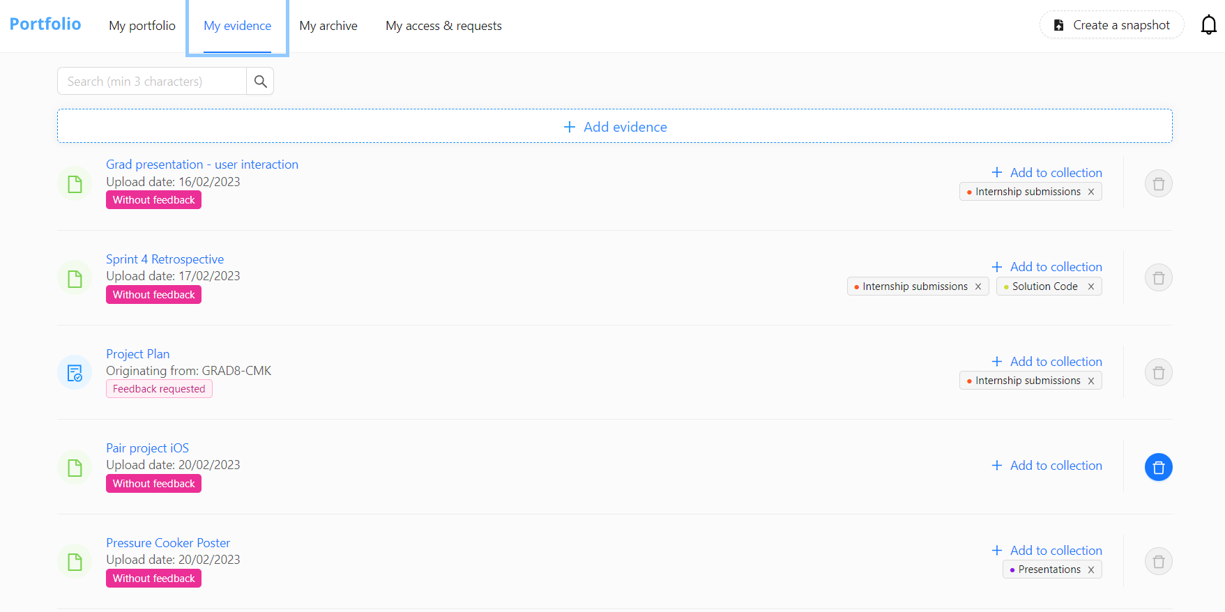

Image 1. Example of current My Evidence Section of Portflow.

My Evidence offers a rather simple list at the moment to help overview the aggregated data and does not offer many features to manage the contents. It is my assignment to change that. The company wishes to offer a better overview and more functionalities to help the students manage the data better.

## 2.2. Goals

The aim of the assignment is to allow students to manage the evidence of their portfolio from My Evidence section. In addition, there should be a better overview of the evidence related statistics. My goal is to modernize and further enhance the evidence overview to allow users to manage their aggregated data (evidence) in a convenient and meaningful way.

The company would like to convert this basic list into a dashboard-like page with an overview of open summaries of all evidence and other useful features. As by aggregating the evidence data, students can have a clearer picture of the portfolio progress.

## 2.3. Approach

The Agile methodology is already used within the company, due to its flexibility and the values matching with the company’s internal culture. Scrum is the chosen framework as it helps manage the work within the teams in a systematic way, enables quick adaptation to the changing situations, encourages feedback and supports frequent releases. I was joining all the activities as an equal team member to stay connected to general team progress on the product. Even if my work focus is on My Evidence section only, it still is part of the Portflow product.

In order to phase the project, I applied Design Thinking Model. The work is roughly split into 5 phases, yet still happens in small iterations. Most of the research took place in the beginning of the internship, however, it continues throughout the duration of the internship (as it is Research based) and I am learning and practising new things at every phase. The Design phase, even though is not reflected in team’s scrum board, was also iterative. I took initiative to meet with all vital stakeholders and draw new designs reflecting on feedback received.

This process was repeated until the satisfactory concept was reached. During the Development and Deployment phase the I gets to create own epics and tasks that get planned into sprints (2 weeklong) together with the rest of the team. Testing and Feedback will be comprised of interaction with the end-users and gathering insights. Lastly, the Wrap-Up phase is where the internship concludes, final deliveries are made, and the defence takes place. The Figure below illustrates the milestones of the project with the rough phasing reflected on a timeline.

Figure 1. Major milestones and phases of the project in time.

# Chapter 3: Process and Results

3.1 Research

In the first month of the internship, I mostly focused on research and analysis as it was important to better understand the company and their products, the industry and the competitors before diving into the user requirements or company’s vision for the product. The (development) environment was set up to provide all necessary access for me to interact with the product. Observing the way of working by participating in all important events was also very informative and helped better understand the challenges ahead.

Next, I learned more about the ed-tech field and made a *Competitor Analysis*. The company already had some information on their competitors, however, I was able to expand and improve the information with their own research. The conclusion has led to better understanding the good and bad practices of similar ed-tech software products.

Furthermore, I received access to internal documents with client requirements and feedback on the Portflow product. The *Document Analysis* helped identify the key requirements and see how the assignment could meet some of them. Next to this, I had an opportunity to visit Fontys and talk to peers and teachers about their experience using Portflow. The feedback was mostly positive and was a delight to hear for the whole development team.

Finally, I gathered enough general understanding to begin the design Phase. Though, it is worth mentioning, that research and analysis does not end with this phase. It carries on alongside any other activities performed. More details can be found in [Research Document](https://github.com/EditaAnomaly/S8-GI-Drieam/tree/main/1.%20Analysis) in the repository.

## 3.2 Design

This phase began with analysing similar products (e-portfolios and LMSs) to see how aggregated data is managed and presented to the user there. There were already some designs made by the lead UX designer of Portflow I could use as a base. In order, to gather more inspiration, extra attention was given to other data management applications both mobile and desktop. In the end, My Evidence page is about managing data, thus this offered useful ideas and insights.

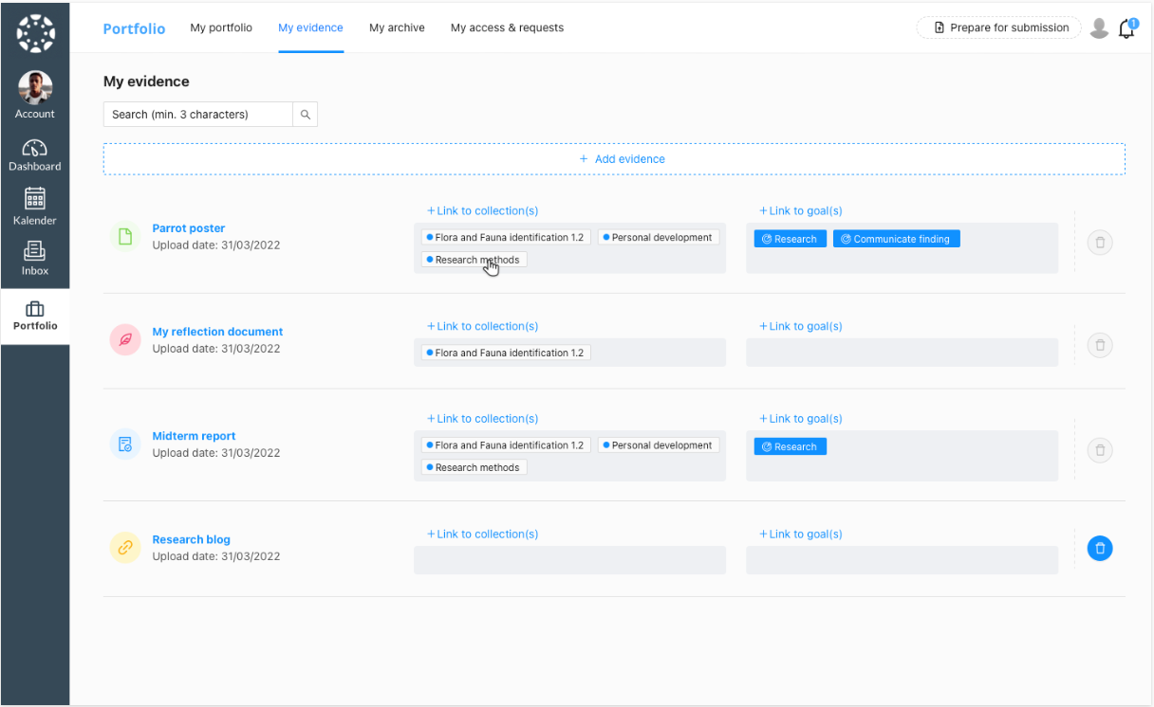

Image 2.Existing designs of My Evidence Section.

Next step was to have extensive talks with the Product Owner (PO) and the lead UX designer for Portflow. I shared their ideas and planned requirements, they shared their ideas and suggestions in return. The agreement was made to make 3 first designs with focus on using a ‘smarter’ list, using cards and using a file map. Several sketches were drawn on paper in different approaches before becoming a digital wireframe on Figma that was presented to PO and UX

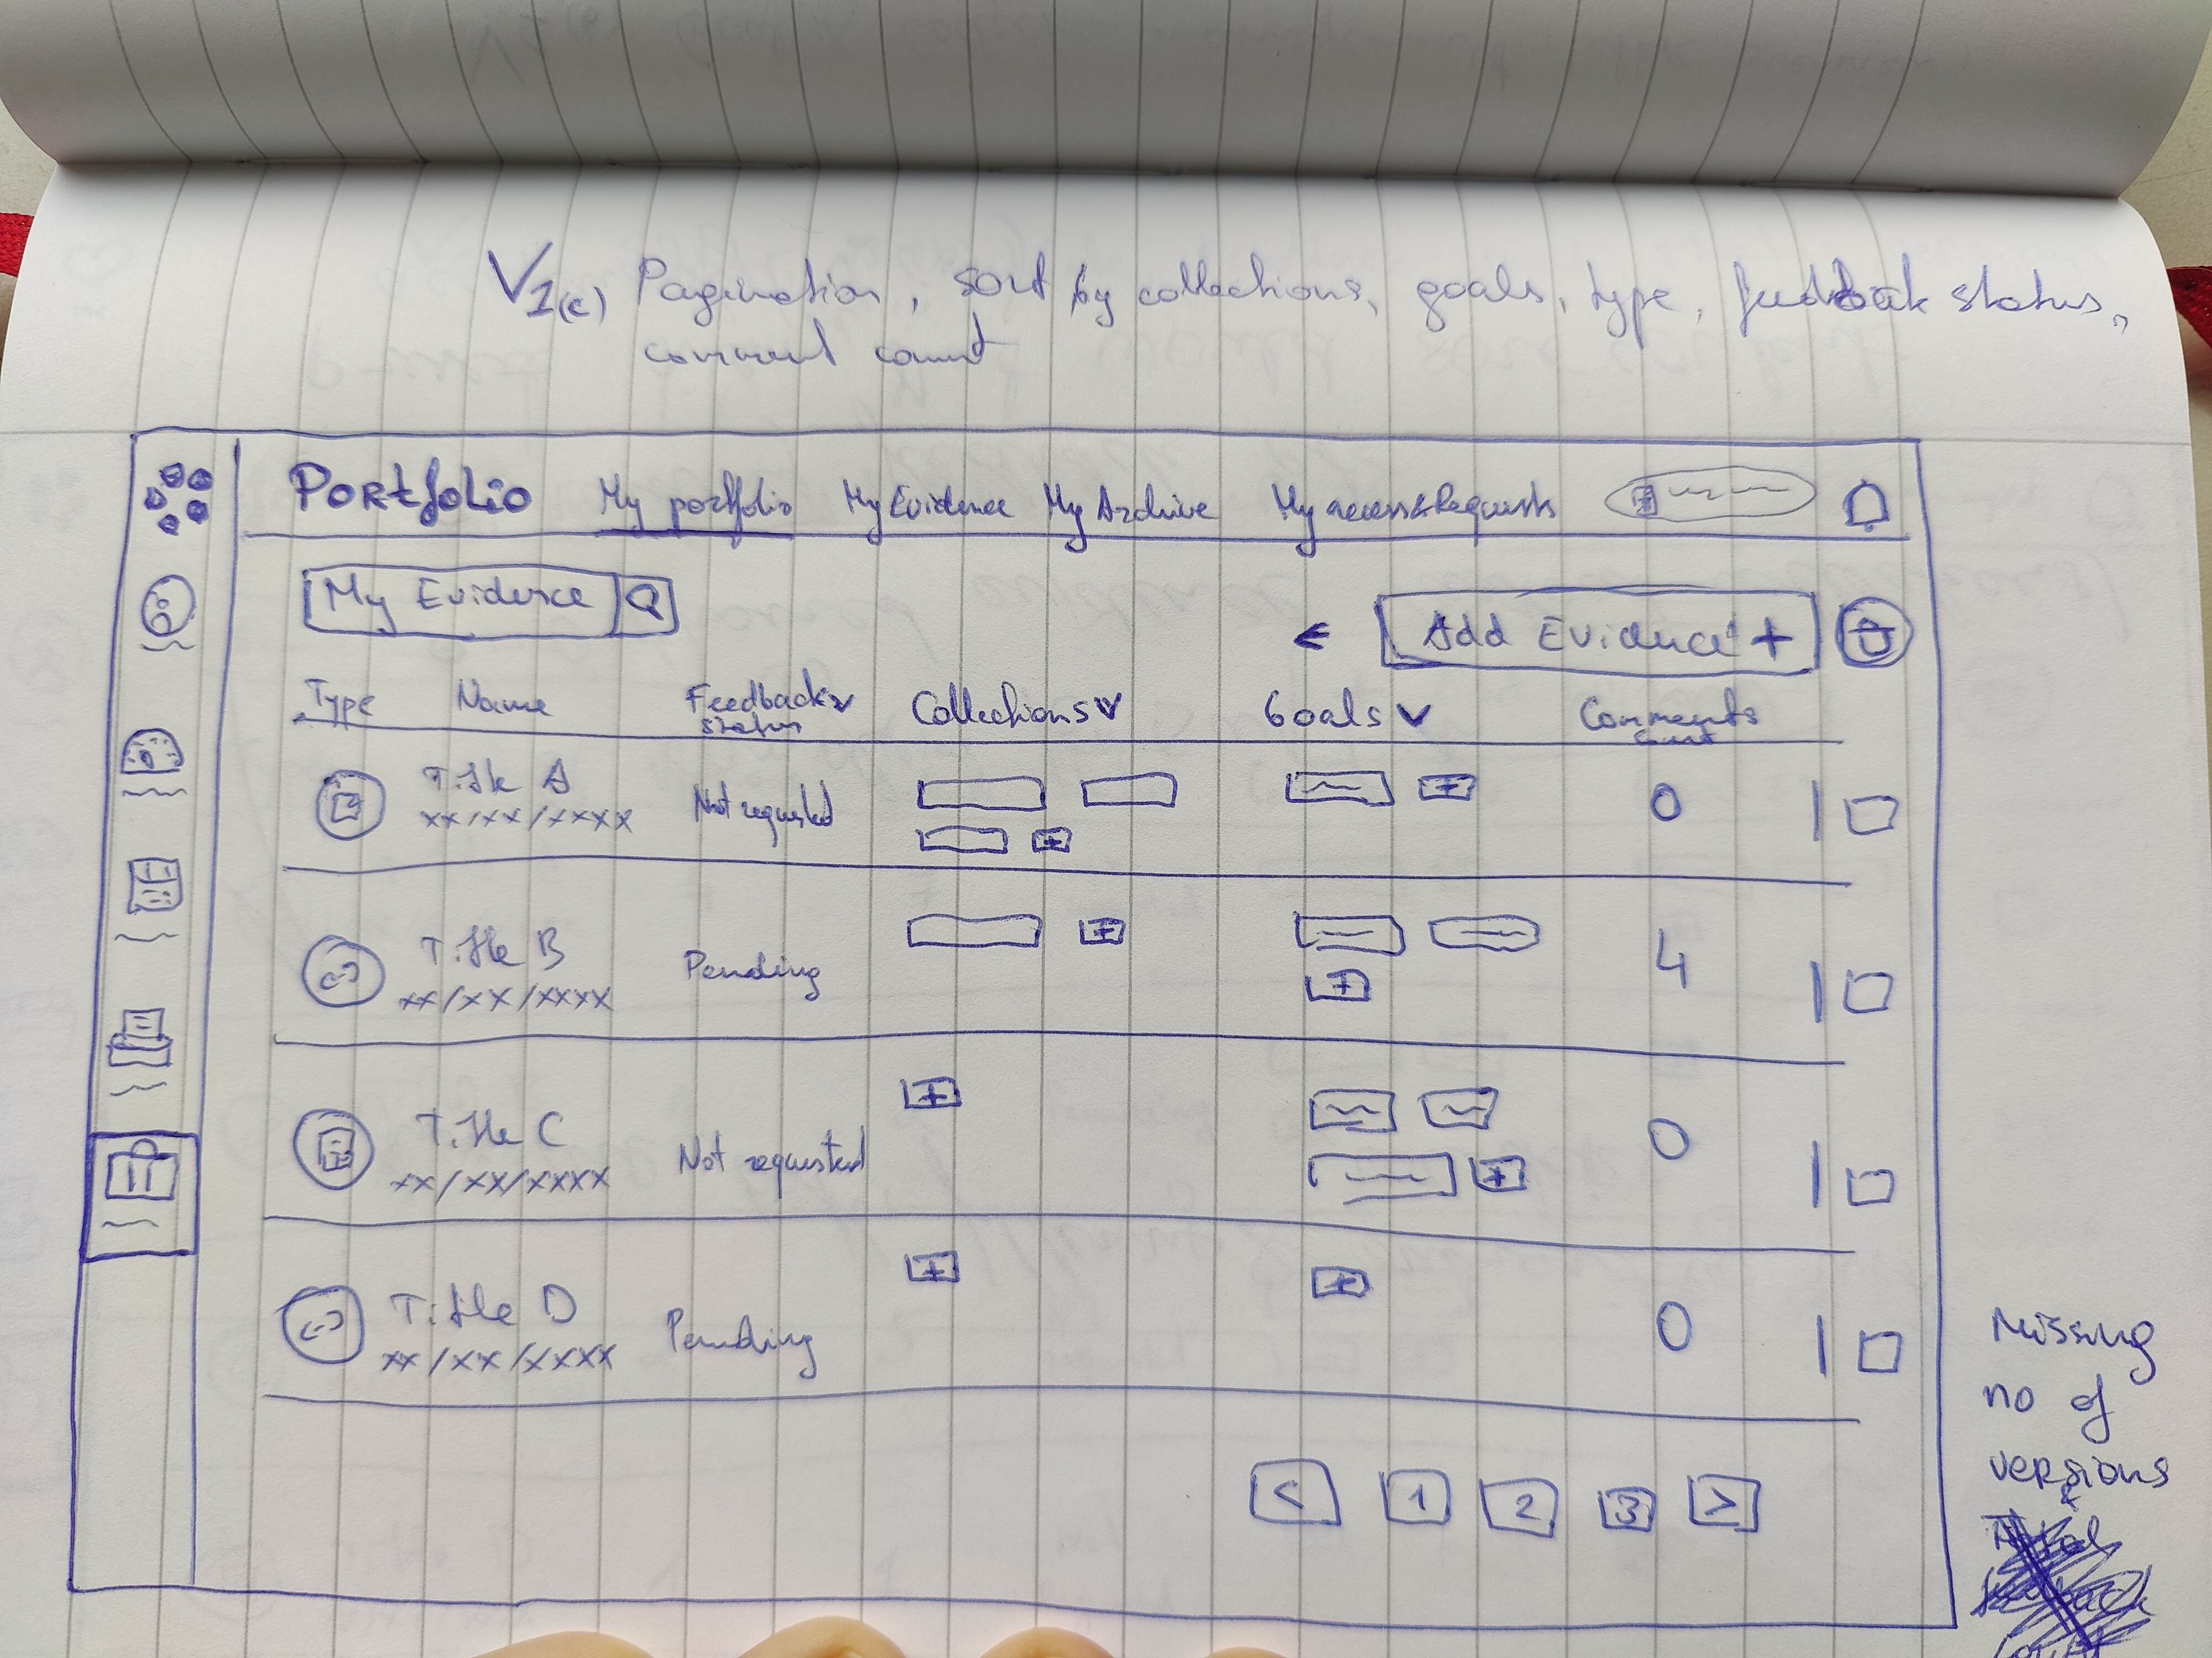

Image 3. One of the initial sketches of my design.

designer for additional feedback. The steps were repeated over several iterations taking the received feedback and advice into account until the right design was created. It was then pitched

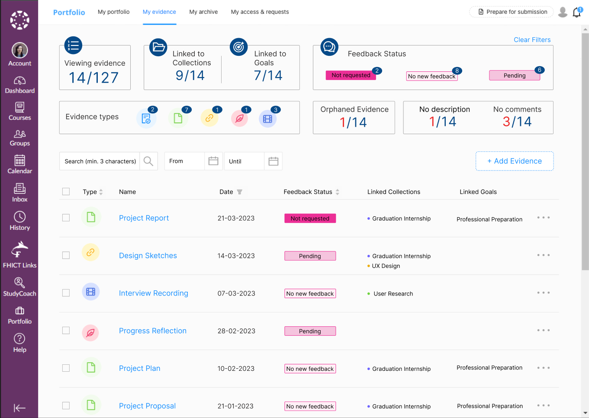

Image 4. The design wireframe that was pitched to the stakeholders to begin the development.

to the stakeholders and approved. Thus, concluding the design phase for now. Though, some modifications may still occur during the implementation phase. More information about design process and inspiration can be found in Requirements and Designing document as well as [Design Document](https://github.com/EditaAnomaly/S8-GI-Drieam/tree/main/2.%20Design). The feedback received is stored in the [Manage](https://github.com/EditaAnomaly/S8-GI-Drieam/tree/main/5.%20Manage) folder of the repository.

3.3 Realization

The Development and deployment phase is the longest part of the internship. I got a chance to implement my ideas and over the course of internship the assignment even grew in its priority. Due to ongoing tenders with various universities and schools the My Evidence page became a dealbreaker feature.

Once the designs were approved, a refinement session was organized with both mentors to help split it into smaller tasks that would be more manageable for a beginner developer (in Ruby and React Typescript). Zenhub integration with GitHub was used to manage the tickets and I made my own epics and issues. First few sprints I did a lot of *Peer Programming* to help learn the basics. Later *Refinements* and issues were mostly led and initiated by me. Each ticket is reviewed by another developer or two, this is a common practice within the company.

Overall, the development was gradual, starting from basics and adding complexity as it progressed. Every few sprints the features were refined, and a set of new tickets were created in

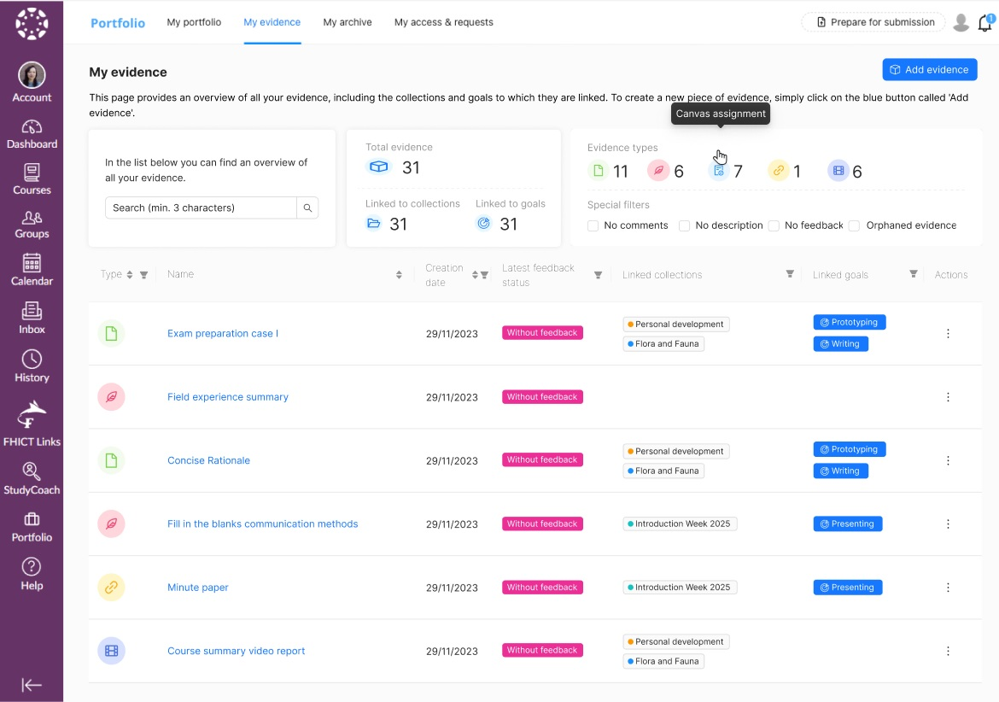

Image 5. The design wireframe used in usability testing.

communication with Scrum Master, PO and mentors. Since, the design was also still getting improved (especially, the dashboard part) the quick adjustment was necessary. Last but not least, I did some practice courses of Ruby, Ruby on Rails and React frameworks, TypeScript and JavaScript during the whole internship to practice the skills too. Some of the [practice courses](https://github.com/EditaAnomaly/S8-GI-Drieam/tree/main/3.%20Realization/Practice%20Courses) and tutorials I did are located in the repository.

# Chapter 4: Conclusions and Recommendations

## 4.1. Advice

The final design version consists of two parts: the table and the dashboard. The table is a big upgrade to the current Evidence list. It provides all the same overview and more with goal tags and explanatory tooltips with the added management features such as sorting and filtering. The format is familiar to the user, but with clear separation of information into columns. This is the part I implemented, and it will be released to production. The second part – the dashboard is what I recommend for the company to still implement. It adds more visual overview and has “actionable” filters that help students to quicker locate evidence that needs attention.

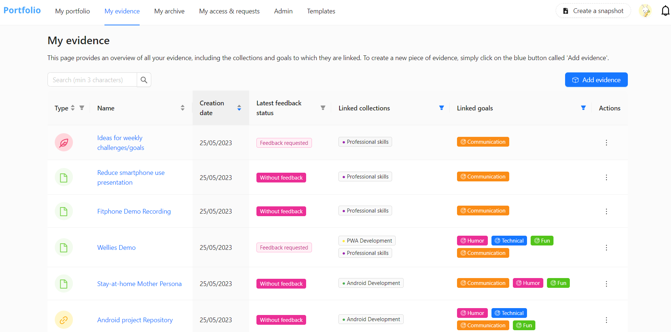

Image 6. Implemented table part of the design.

In order to verify my designs, I performed tests with actual users of Portflow. The Test Plan, Recordings and Raw Results can be found in the [User Testing](https://github.com/EditaAnomaly/S8-GI-Drieam/tree/main/2.%20Design/User%20testing) folder of the Design part of the repository. Every test participant agreed that it is an improvement to the current evidence list and gives more reason to use this feature of the digital portfolio. However, I received valuable insights and usability challenges that align well with my suggestions for the future improvement of the application. I would divide my recommendations into design or implementation, process and ethical.

The design or implementation suggestions are the things that could still be improved to make the application more functional and user-friendly. I did not implement them myself due to complexity, time limitation, being out of my assignment scope or simply identifying them too late in the internship. First, usability challenge that also was clear during user testing was the sorting on the evidence type column. Sorting is an ant Design component and the column itself becomes the sorter, making filter a small button inside a bigger one. The users kept mis-clicking the column and getting confused. I would definitely recommend removing the sorting on this column as filter is a more functional of the two. Filters can be combined, while sorters obviously cannot. Next, the goal status colours are too bright and stand out too much. Together with “Without Feedback” tags they appear almost as primary buttons. Thus, using a similar approach to collection tags with highlights would be a more consistent and user eye-friendly approach. In addition, both of these recommendations are in-line with the aim of making Portflow more accessible, therefore, need to be corrected either way. What is more, it would be incredibly useful to the users to be able to filter evidence by date (from - to). It would enable total control of locating evidence based on its

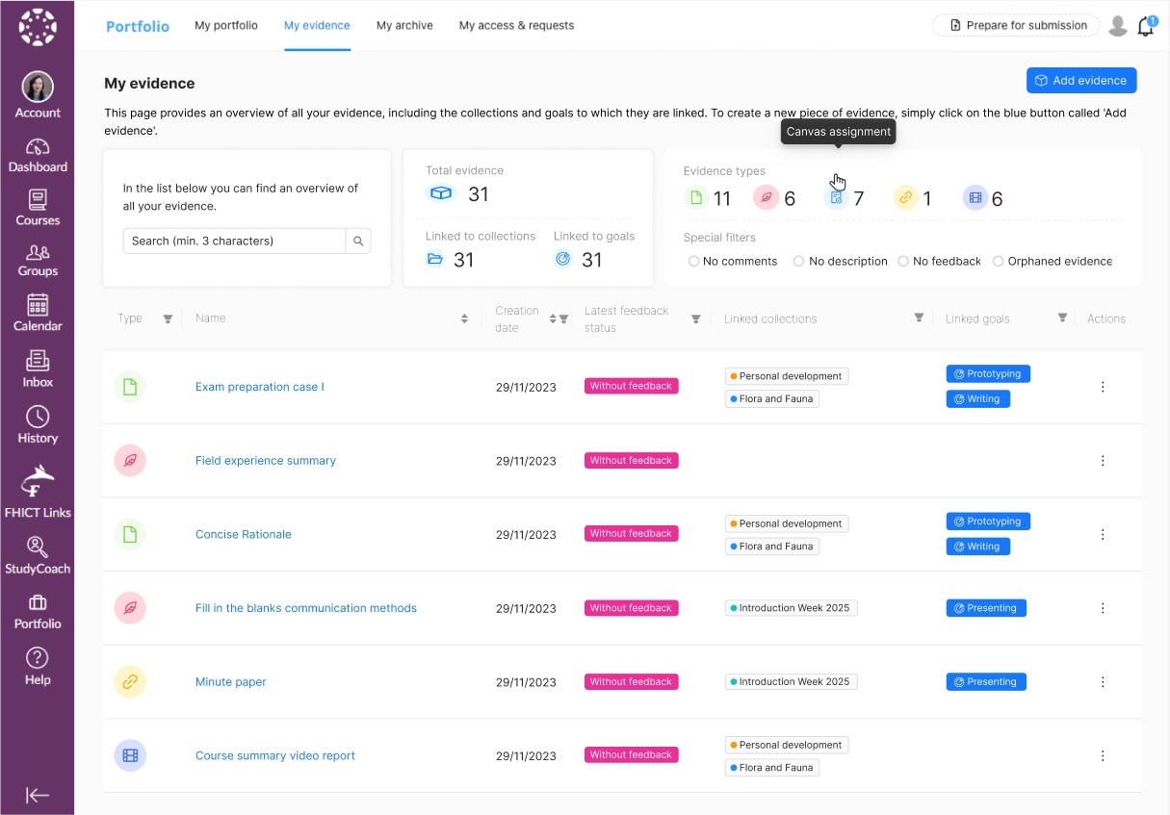

Image 7. Final design recommendation to the company.

creation date. Last, but not least, a nice option to avoid ambiguous naming like “orphaned evidence” would be to add “Not linked” in “Linked to Goals” and “Linked to Collections” filter options. This way students could still locate orphaned evidence by themselves, without the dashboard. Finally, the last suggestion is slightly out of my scope. During the tests, I observed students searching for goals or collections management options in the Evidence Detailed View. It

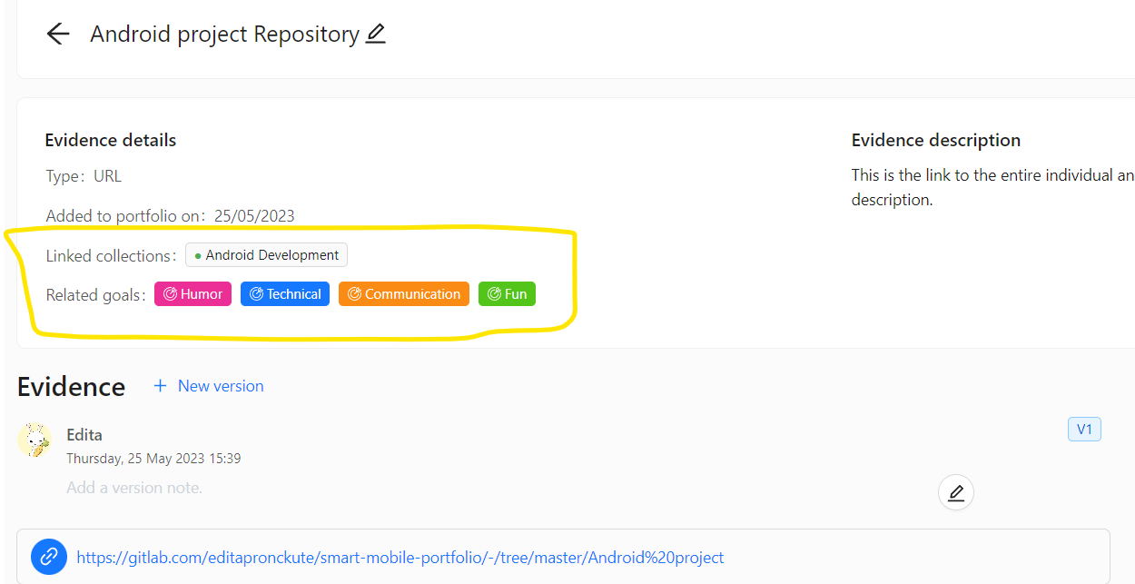

Image 8. Evidence Details View with highlighted linked goals and collections.

is a logical expectation as it is not visible in the table overview. Thus, next to having actions I would recommend adding an option to manage linked goals and collections from the Evidence Detail View. The tags are already displayed there, yet not editable (see image 8 above). Therefore, this page would be a consistent place to edit a single piece of evidence.

The next couple of suggestions are more about the process or the way of working at Portflow team. It is based on the [research](https://github.com/EditaAnomaly/S8-GI-Drieam/tree/main/1.%20Analysis) done and my own practice. First, is the application of Scrum in daily practice. Currently, the retro meeting falls into the middle of another sprint, which was something that kept me confused about the sprints. I would sincerely recommend moving it either right after the demo to close the sprint well or attach it to the Sprint Planning of the new sprint. This way the team can reflect on how the previous sprint went and apply the suggestions or take the concerns into account when planning the new one straight after. The other process related suggestion is to consider and prepare well for transition from Zenhub to Jira. Portflow is a successful product and in the last 5 months I could see it grow in complexity, value and customer pool. It will clearly grow in team size, amount of improvements and maintenance needs, therefore, moving to Jira would open more options for managing the project, support more integrations with other applications, have less downtime and even provide more reporting tools.

Last part of recommendations is more for the client communication. I had the opportunity to talk to teachers and students that are using Portflow in the beginning and at the end of my internship. In addition, I carried out an [ethical analysis](https://github.com/EditaAnomaly/S8-GI-Drieam/blob/main/4.%20Advice/TICT%20Digital%20Portfolio.pdf) of the Portflow. It has led me to realize how big the gap is between how the application is intended to be used and how educational institutions actually apply it for their needs. Having this wiggle room is not a negative point, however, communication with the clients as well as encouraging them to communicate this with their end-users is very important. For example, Drieam organizes various events where they gather feedback about the product from their clients, introduce new features, discuss various application ways and potential improvements. It is really important this information gets passed down to actual end-users – students and teachers. Portflow has the potential to improve a lot of student – teacher work and communication, but it is important to ensure it does not completely replace it. My suggestion is to encourage more knowledge sharing sessions between students and teachers, however, this is mostly in control of the institutions themselves.

Overall, the improvements to My Evidence page provide much more features and thus more control for the student which is well in-line with student-driven product vision of the company. It gives a better overview from a main evidence page with great sorting, filtering and functional statistics. However, more improvements can and are being made as it is a living product.

## 4.2 Management

I had full responsibility over the project to multiple stakeholders. I had to manage the expectations of the company, design and develop solution with the end-users in mind while ensuring I keep up with the learning goals of the Graduation Internship. I was able to follow the planning set out in the early stages of the internship. Some adjustments had to be made along the way as the design was being improved while developing. However, it is part of the agile way of working with frequent feedback and the need to quickly adapt to changes. I took initiative to prepare pitches, make company demos and presentations while maintaining frequent communication with the PO, UX designer, dev team and university tutor. More details about management part of the internship can be read in the [portfolio wiki](https://github.com/EditaAnomaly/S8-GI-Drieam/wiki/5.-Management).

Personal Reflection

In the early stages of the internship, I had to take ownership and responsibility of my assignment. I am much more comfortable working in a team and sharing ideas, task and overall responsibility, having this all depend on me alone was a little overwhelming. Due to employee holidays and mentor leaving the company, I realized soon that if I am not proactive, this assignment will fail. Therefore, I have put extra effort into planning and learning early on. I still faced many challenges but worked hard to overcome them.

One of the first challenges was about keeping track of my process from daily activities to the milestones of the internship. To help me with this, I kept the phasing plan I created in the Project Planning stage nearby at all times, but also kept a log of my tasks for each day. I have learnt this from my previous internship where I kept an actual journal. This time, I used a digital application called Obsidian. It was very helpful to keep all vital notes in one place. From daily to-dos to feedback notes or quick code solutions that are repetitive. These [notes](https://github.com/EditaAnomaly/S8-GI-Drieam/tree/main/5.%20Manage) are added to the portfolio repository, under the Management section.

Being part of the company but still a university student was another challenge, that I struggled with. I love the fact that what I was creating will be used by other students and educators and found it very inspiring. It served as a great motivation to work on implementing as much as possible. Thus, my passion was driving me to focus on the assignment, often detaching me from my responsibilities as a student. I needed to remind myself multiple times that this is an assignment for my university, so that I could graduate and thus, my priority should lie with completing my research and meeting the learning criteria of this semester.

Since, I am originally a software student, focusing on User Interaction was adding to this duality of roles. I experienced several blocks along the way, where I was not sure what the next best step is or what is the best tool or approach in the Design Phase. During these doubts I turned to the UX designer of the company as well as my university tutor, they both gave me ample advice and guidance during this period, and I have learnt a lot from both of them. Interestingly, not only designing made me feel a bit out of my depth sometimes. The same happened with development too. The company uses some languages and frameworks that were completely new to me. Practice courses eased me a little, but there was still a lot of learning from my fellow developers that caused a lot of “growth pains”.

Lastly, I had a very personal struggle on my mind since the beginning of my study. That is my future career choice. This is a second degree and I pressured myself to decide what I want to do with my career. Luckily, this internship allowed me to try several new things and briefly take on different roles (designer, developer, researcher, tester etc.) and experience mentorship on professional and personal level.

In the end, I genuinely enjoyed this internship, the skills I learned, the connections I build and the memories I made were well worth the struggles. I am proud of what I have achieved and for stepping out of my comfort zone as that is where the real growth begins. I learned many new things and a got to know myself a little better.

References

Crawshaw, F. V. (2021, March 24). *Enterprise Filtering: UX Pattern Analysis*. Retrieved from Pencil and Paper: https://pencilandpaper.io/articles/ux-pattern-analysis-enterprise-filtering/

Daley, S. (2022, August 8). *Edtech 101*. Retrieved from Built In: https://builtin.com/edtech

Das, S. (2022, August 11). *Learning Tools Interoperability: The Future Of The LMS*. Retrieved from eLearning Industry: https://elearningindustry.com/learning-tools-interoperability-the-future-of-the-lms

Design Council. (2019, May 17). *Framework for Innovation: Design Council's evolved Double Diamond*. Retrieved from Design Council: https://www.designcouncil.org.uk/our-work/skills-learning/tools-frameworks/framework-for-innovation-design-councils-evolved-double-diamond/